Assignment 5

Name- Kaveri Avinash Jarhad

Q1. Display System Information
Write a shell script that displays:
- "Welcome to Linux"
- Current username
- Current working directory
- Current date and time
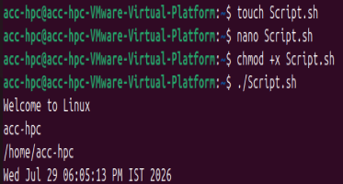

Q2. Display Environment Variables
Write a shell script that displays:
- User's home directory
- Shell name
- Username
- Hostname
Hint: Use environment variables
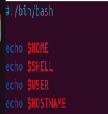
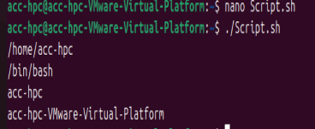

Q3. Read User Information
Write a shell script that asks the user to enter:
- Name
- City Then display: Hello <Name>
Welcome from <City>
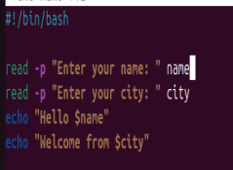
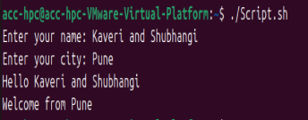

Q4. Display Contents of a File
Write a shell script that asks the user for a filename and displays its contents.

Assume the file exists.
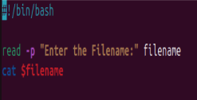
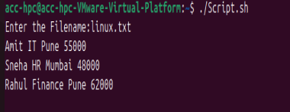

Q5. Count Lines in a File
Write a shell script that accepts a filename from the user and displays only the number of lines in the file.
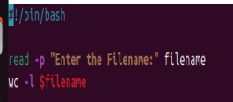
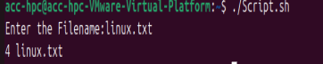

Q6. Search a Word in a File
Write a shell script that:
- Accepts a filename.
- Accepts a search word.
- Displays all matching lines.
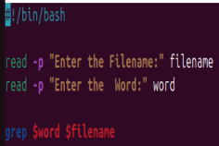
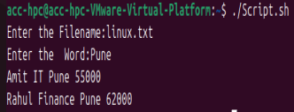

Q7. List Directory Contents
Write a shell script that:
- Accepts a directory path from the user.
- Displays all files in that directory in long listing format.
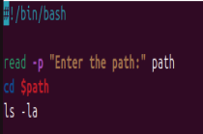
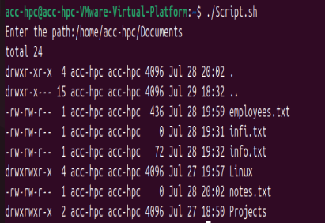

Q8. Display File with Line Numbers
Write a shell script that asks the user for a filename and displays the file with line numbers.
Condition: Do not use cat -n.
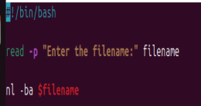
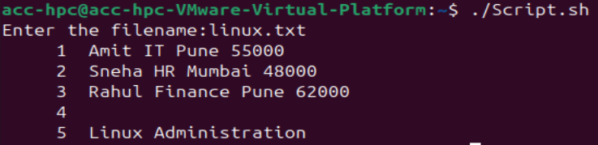

Q9. Display Command Output in a File
Write a shell script that creates a file named systeminfo.txt containing:
  - Current date
  - Current working directory
  - Logged-in username
Display the contents of the file after creating it.
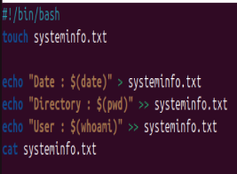
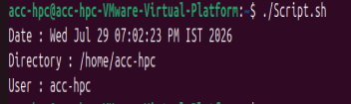

Q10. Multiple Commands in One Script (Tricky)
Write a shell script that performs the following tasks:
- Displays the current directory.
- Lists all files, including hidden files.
- Displays all environment variables.
- Prints "Script Executed Successfully" at the end.
